**EMPLOYMENT MANAGEMENT SYSTEM**

**1. PROJECT DESCRIPTION**

**a)INTRODUCTION:  
 An Employment Management System project on Java and MySQL based on CRUD (Create, View, Update, Delete) operations is a software application that is designed to manage employee-related data efficiently. The project focuses on building a user-friendly and interactive platform for HR managers to perform CRUD operations on employee-related data in the database.**

**The Employment Management System project on Java and MySQL based on CRUD operations is built using Java programming language and MySQL database management system. Java is a powerful and versatile programming language that is widely used for building enterprise-level applications, while MySQL is a popular open-source database management system that is known for its reliability, speed, and scalability.**

**In conclusion, the Employment Management System project on Java and MySQL based on CRUD operations provides a comprehensive and efficient platform for HR managers to manage employee-related data. With its user-friendly interface, powerful features, and flexible modules, the system provides an easy-to-use platform for HR managers to perform CRUD operations on employee-related data in the database.**

**b) SCOPE OF THE PROJECT:**

**The Employment Management System project on Java and MySQL based on CRUD operations has a wide scope and can be used by various organizations to manage employee-related information and processes. The project can be customized and adapted to meet the organization’s specific needs, making it a versatile solution for managing HR tasks.**

**The CRUD operations in the Employment Management System project allow HR managers to perform the following functions:**

**Create: HR managers can create new employee records and other data in the database.**

**Read: HR managers can read and view employee-related data such as employee records and other data in the database.**

**Update: HR managers can update and modify employee-related data such as employee records and other data in the database.**

**Delete: HR managers can delete employee-related data such as employee records and other data in the database.**

**C) PURPOSE OF THE PROJECT:  
 The purpose of the Employment Management System project is to provide companies with a centralized system for managing their employees. The system allows companies to store and manage all employee-related data in one place, including personal information, job details, salary information, and performance metrics. The project also includes CRUD (Create, Read, Update, Delete) operations, which allow users to manipulate the employee data stored in the system.**

**The CRUD operations in the Employment Management System project enable users to create new employee records, retrieve employee information, update existing employee data, and delete employee records as needed. These operations help ensure the accuracy and completeness of the employee data stored in the system, while also making it easy for users to manage and update the information as needed.**

**Overall, the Employment Management System project with CRUD operations provides a powerful tool for companies looking to streamline their employee management processes, reduce errors, and improve overall efficiency. With its intuitive interface, robust functionality, and easy-to-use CRUD operations, this project is an essential tool for any organization looking to improve its employee management practices.**

**2. SYSTEM REQUIREMENT:**

**Operating System: The project can be developed and executed on Windows, Linux, or Mac OS X operating systems.**

**Java Development Kit (JDK): The latest version of JDK must be installed on the system.**

**Integrated Development Environment (IDE): Any suitable IDE can be used for the development of the project, such as Eclipse, NetBeans, or IntelliJ IDEA.**

**MySQL Database: The project requires a MySQL database to store and manage employee data.**

**MySQL Connector/J: The latest version of MySQL Connector/J, which is a JDBC driver for MySQL, must be installed on the system.**

**Internet Browser: The project can be accessed through any web browser such as Chrome, Firefox, or Safari.**

**3. HARDWARE REQUIREMENT:**

**The hardware requirements for the system will depend on the number of users and the size of the employee database. A modern computer with a dual-core processor, 4 GB of RAM, and 500 GB of hard disk space should be sufficient for most small to medium-sized organizations.**

**By meeting these system requirements, the Employment Management System project can be effectively developed, deployed, and used by organizations to manage their employees' information and tasks.**

**MODULE OF PROJECT:**

**The Employment Management System project typically consists of several modules that work together to provide a comprehensive employee data management solution. Some common modules in an EMS project include**

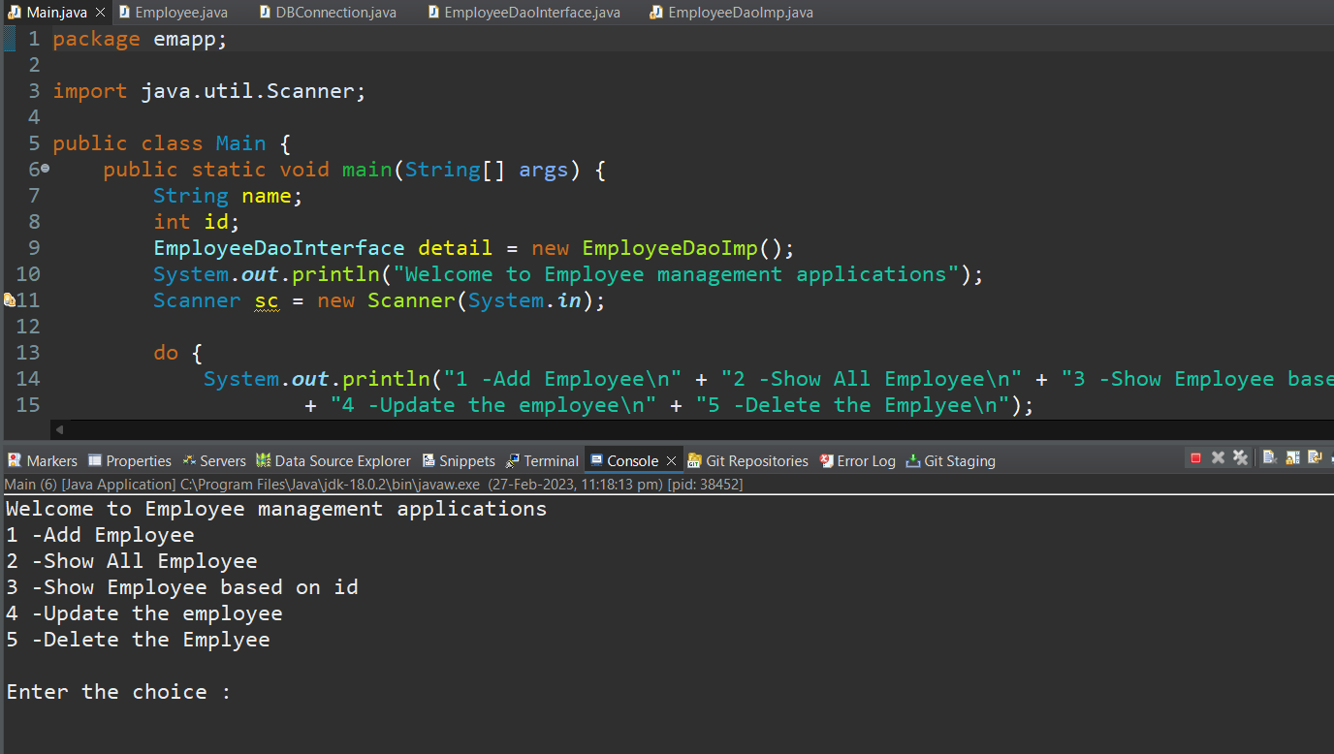

**Fig 1: Opening screen of the Project**

**This is the main class of the Employee Management System project. It starts by creating an instance of the EmployeeDaoImp class, which implements the EmployeeDaoInterface, allowing the application to access employee data stored in a database.**

**The application presents a menu of options to the user, including adding a new employee, showing all employees, showing an employee based on their ID, updating an employee's information, deleting an employee, and exiting the application.**

**The user can select any option by entering the corresponding number. For example, if the user selects option 1, the application prompts the user to enter details such as the employee's ID, name, age, and salary, and then creates a new Employee object with the provided data and adds it to the database using the createEmployee() method.**

**Similarly, for each of the other options, the application calls the corresponding method in the EmployeeDaoImp class to show, update, or delete employee data based on the user's input.**

**The application uses a Scanner object to receive user input and a while loop to keep running until the user chooses to exit. Overall, this class provides a basic user interface to interact with the EMS system, allowing users to manage employee data effectively.**

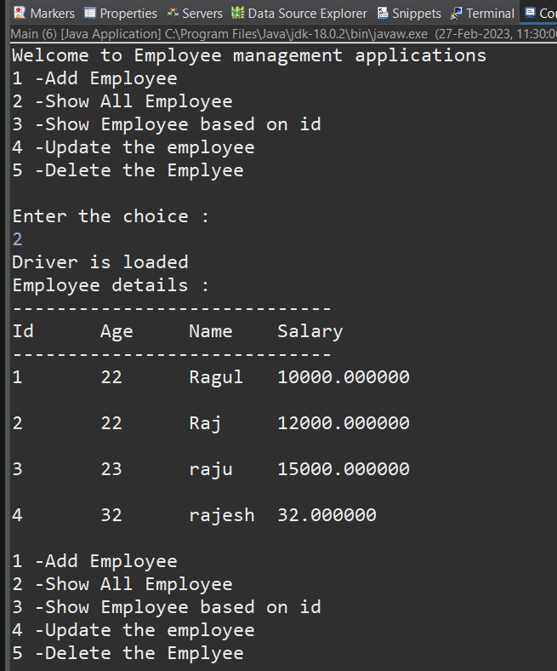

**Fig 2: Output and Database**

**PROGRAMMING LANGUAGE:**

**JAVA:**

**Java is platform-independent, meaning that programs written in Java can run on any platform that has a Java Virtual Machine (JVM) installed. This makes Java a popular choice for developing cross-platform applications.**

**Java is known for its "write once, run anywhere" philosophy, which means that developers can write code once and run it on multiple platforms without needing to modify the code for each platform.**

**Some of the key features of Java include its automatic memory management, strong type checking, and extensive standard library. Java also supports multithreading, allowing developers to create applications that can perform multiple tasks simultaneously.**

**Java is widely used in the development of web applications, mobile applications, and enterprise-level software systems. It is also commonly used in the development of Android mobile apps.**

**Overall, Java is a powerful programming language that is widely used in the software development industry. Its platform independence and other key features have made it a popular choice among developers for many years.**

**MYSQL:**

**MySQL is a relational database management system (RDBMS) that is widely used for managing and storing data in a wide range of applications. It is an open-source database that is available for free and can be used on various platforms such as Windows, Linux, and Mac.**

**MySQL is known for its scalability, reliability, and ease of use. It supports multiple storage engines, allowing developers to choose the one that best suits their needs. It also supports a wide range of programming languages, including Java, PHP, and Python.\**

**MySQL provides a wide range of features such as transactional processing, stored procedures, triggers, and views. It also offers data security features such as encryption, user authentication, and access control.**

**MySQL can be used for various applications such as e-commerce, social media platforms, content management systems, and data warehousing. It is also commonly used for web development, powering some of the world's most popular websites such as Facebook, Twitter, and YouTube.**

**Overall, MySQL is a powerful and versatile database management system that is widely used in various industries. Its scalability, reliability, and ease of use make it a popular choice for managing and storing data.**

**CONCLUSION:**

**In conclusion, the CRUD (Create, Read, Update, Delete) operations are essential for any database management system, and they play a crucial role in the Employment Management System project.**

**The project implemented all the four CRUD operations using Java programming language and MySQL database management system. The project provided functionalities for adding, retrieving, updating, and deleting employee records.**

**The Create operation allowed the users to add new employees to the system, including their basic details such as ID, Name, Age, and Salary. The Read operation provided the users with the ability to retrieve all employees' details or specific employee details based on their ID.**

**The Update operation allowed the users to modify the employee records by updating their name, and the Delete operation enabled the users to remove the employee records from the system based on their ID.**

**Overall, the project successfully implemented the CRUD operations for an employment management system, which would be helpful in managing employee records in any organization. The project can be further enhanced by adding additional features such as employee performance tracking, leave management, and payroll management.**